**Image Seam-Carving by Controlling Positional Distribution of Seams**

Mahdi Ahmadi, Nader Karimi, Shadrokh Samavi

the proposed method is as simple as the original seam-carving, it has better performance in terms of Retargeted Image Quality Assessment (RIQA) measures.

This method using graph-cut. In its graph, the representation of the seam-carving method, the image pixels are nodes of a directed graph. To find the best

seam to be deleted, the graph-cut algorithm is used in each iteration. Graph-cut is a mathematical tool to cut a graph so that the removed arcs have the least (or greatest) summation of weights among all other possible cuts.

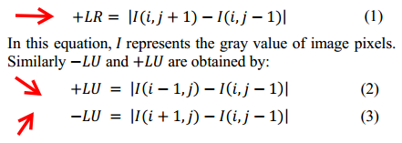

In this paper, an energy term E/ramp is added to +LR that regularly controls the distribution of seams. By adding E/ramp in this energy term, the seams are so distributed that there will be less coagulation in seams. The lower density of seams means that the seams are distributed in more image regions and are not placed next to each other. This term is the energy allocated to the pixel p/i,j and is calculated by this equation:



Authors set parameters of alpha, R/1, and R/2 to 0.0625, 4, and 5.